Week 4  Home Learning | Literacy Tasks | Numeracy Tasks | Health and Wellbeing Tasks
Monday | Spelling activities  - Open the PowerPoint and look at the new sound.  - Ask someone to read each of the spelling words to you.  - Count the sounds in each word (for example th-e-n – 3 sounds).  - Try and write each word without looking at the PowerPoint.  - Check each word before you move onto the next word.  - Challenge! Try and write as many words as you can think of that have the same spelling pattern as your words for this week. | Basic Facts  - Go to the basic facts activity folder.  - Practise your basic fact (10 minutes daily if you can).  Multiplication  Make equal groups using pictures, numbers and words e.g. Can you show me 2 children with 4 sweets each? Can you draw 3 cakes with 2 cherries on each?  Organise materials to make an array. Use small toys, buttons etc.  Say the multiples of 2s, 5s, 10s etc. to find how many of an object there are in a group.  Click on the links for videos and games to help develop understanding. | - Emotional Check-in  Physical wellbeing  Do stretches to warm up  Run on the spot for 1 minute  Do 20 steps moving from side to side  Do 10 star jumps  Do 10 step ups (on a stair, step etc.)  Make up your own moves and do them 10 times!
Tuesday | Spelling and Handwriting  Write your words out in fancy, curly or block  writing.  Handwriting https://www.doorwayonline.org.uk/activities/letterformation/  Activities:  Watch how the letters are formed, press and follow or free draw the letters on the screen.  Practise writing letters in your jotter. Focus on making sure your letters are written correctly.  Practise writing these sentences:  In Italy, Jed, Karen and Liam ate pizza.  My best friends are Nelly, Otis and Poppy. | Basic Facts  - Go to the basic facts activity folder.  - Practise your basic fact (10 minutes daily if you can).  Multiplication  Create a matching game. Cut small pieces of card and write on it facts and answers for the times table you want to practise. Turn them over and try and match the multiplication with the answer. As well as straightforward 2X5 some could be written as ‘2 lots of 5’, ‘2 groups of 5’, ‘2 multiplied by 5’, so children get used to the vocabulary of multiplication.  Complete a colour by number picture. Draw a simple picture and ask someone to write multiplication facts inside different parts of it and write the colour code beside the answers so you know what colours to use.  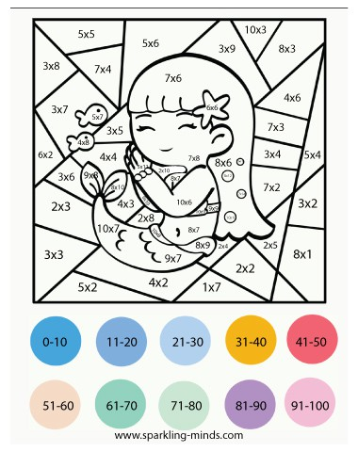 | - Emotional Check-in  Mental and emotional wellbeing  Make a card or postcard to send to someone you miss. Get creative! Draw, paint or cut and stick to design the card showing something that the person you miss really likes. Write a positive, kind message inside.
Wednesday | Spelling - ask someone to play spelling tennis with you.  Reading  Read a book and complete one of the following activities:  1.Write about your favourite part of the book  2. Make up 5 quiz questions for your book. Ask someone else to read the book and then see how many of the quiz questions they get correct.  3. Make finger puppets of the characters in the book and retell the story.  https://home.oxfordowl.co.uk/  Read a new book online and complete the games to go with it. | Basic Facts  - Go to the basic facts activity folder.  - Practise your basic fact (10 minutes daily if you can).  Measurement (Length)  Measure using non standard units. Estimate and measure in handspans, e.g. how many handspans do you think the kitchen table, the sofa, your bed etc. is? Measure to check how close you were to the estimate. Write down your estimates and your actual measurements.  https://www.youtube.com/watch?v=uAVL-mOdZUs | - Emotional Check-in  Physical and mental wellbeing  Try out some guided dance workouts on Go Noodle, Just Dance or try a Joe Wicks workout.
Thursday | Spelling - get someone to test you on your spelling words.  Writing  Look at the pictures of the different characters on the powerpoint. Choose one and write 5 sentences describing the character. Remember to use describing words. To help you, think about describing the character’s hair, skin, eyes, nose, mouth. Think about the colour, shape and size.  e.g. Her hair is long, brown and frizzy. | Basic Facts  Get someone to test you on your basic fact for this week. Remember you need to get them all correct in 1 minute.  Measure using non standard units. Choose some smaller objects to measure e.g. pencil, book, paintbrush etc. Estimate and measure using either paperclips,cubes, buttons, lego (whatever you choose they must all be the same size!). Write down your estimates and your actual measurements. | - Emotional Check-in  Mental and emotional wellbeing  Create your own wellbeing jar.  Get an empty jar and glue on shapes made from tissue paper,foil, thin paper, photos...whatever you like! Think of something you would like to do in the future, write it on a piece of paper and place it inside your decorated jar.

